**2. Web Application Deployment with AWS EC2, Load Balancer, and Route 53**

**PROBLEM STATEMENT:**

Efficiently deploy and scale a web application, ensuring high availability and optimal performance by leveraging AWS EC2 instances, an Application Load Balancer (ALB), and Route 53 for DNS routing.

**USE-CASE SCENARIO:**

Imagine you have developed a web application that is gaining traction, and you need a robust infrastructure to handle increasing traffic. Deploying it on AWS EC2 instances, utilizing an ALB for load balancing, and configuring Route 53 for DNS routing ensures seamless scalability, reliability, and efficient distribution of incoming requests across multiple instances.

------------------------------------------------------------------------------------------------

**SOLUTION:**

**PRE-REQUIREMENTS:**

* AWS Cloud
* EC2
* Application LoadBalancer
* Route 53

**Step:1 – Create AWS EC2 Instances:**

* First login into your AWS instance:

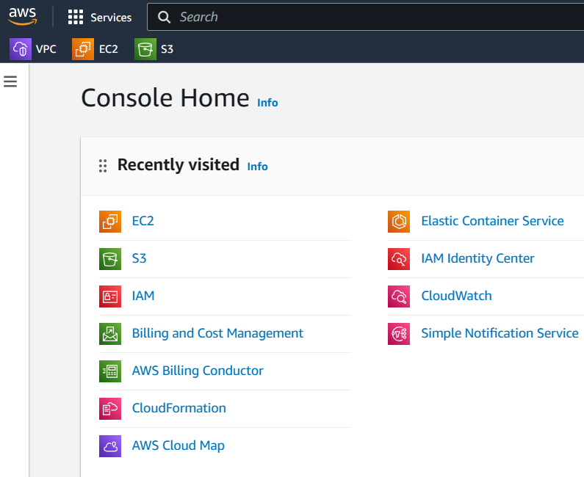

* Then on service search panel search EC2, click that one:

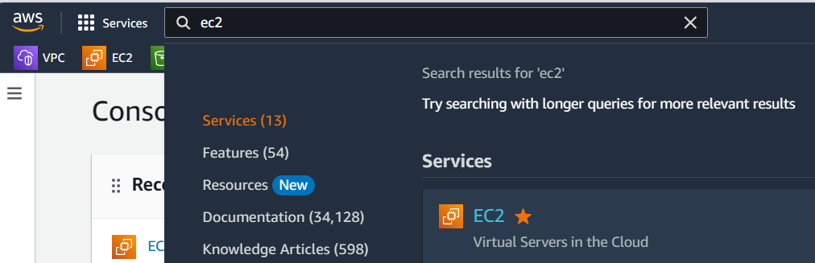

* Then click launch instances, for creating an EC2 instance:

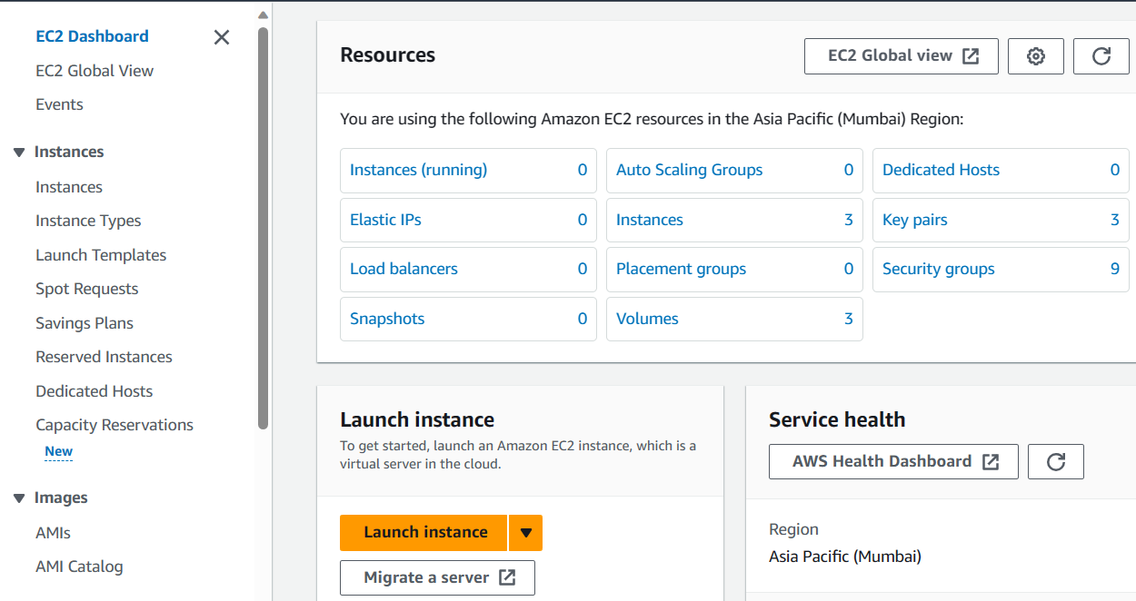

* Then name the instance according to your preferences:

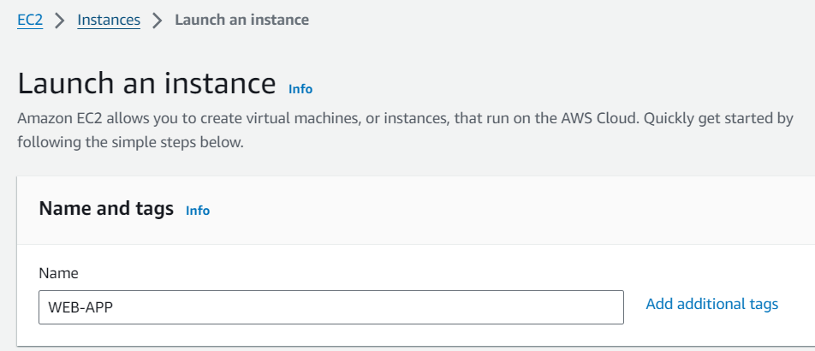

* Then select the operating system according to your preferences:

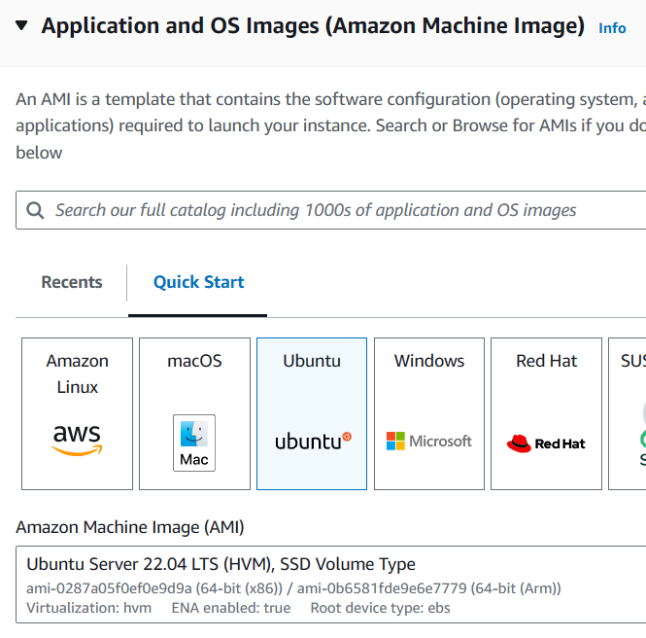

* Then select the instance type: according to your preferences, but here I am selecting **t2.micro**

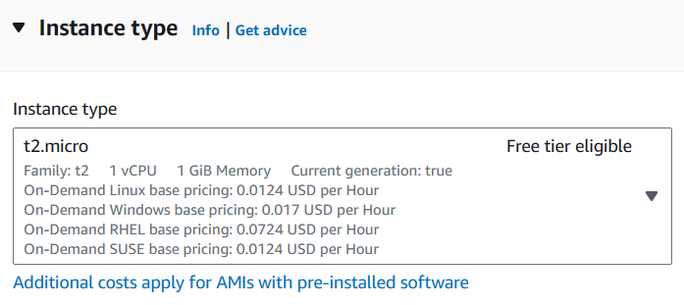

* Then select the key pair, according to your preferences, but here I am **proceeding with key pair option**, you can go with proceed with **without key pair option:**

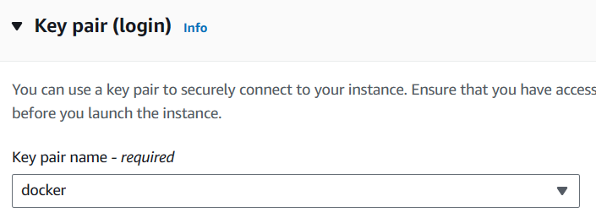

* Then keeping the default options under network settings:

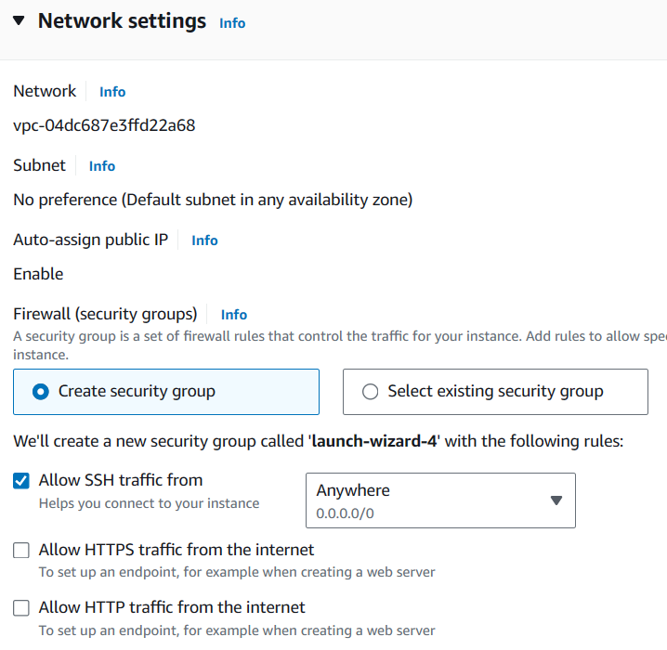

* Then keeping default options for the rest of the settings, click launch instance:

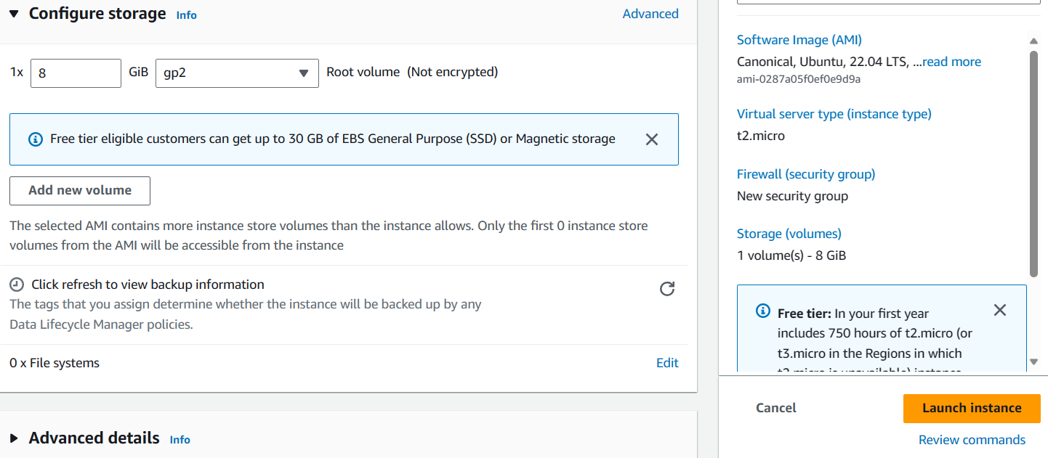

* The instance has been launched successfully:

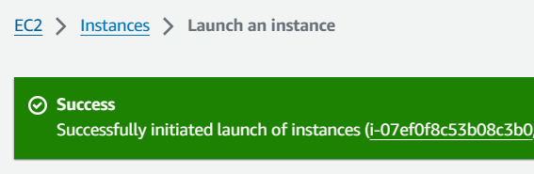

* Same like this we must create another instance:

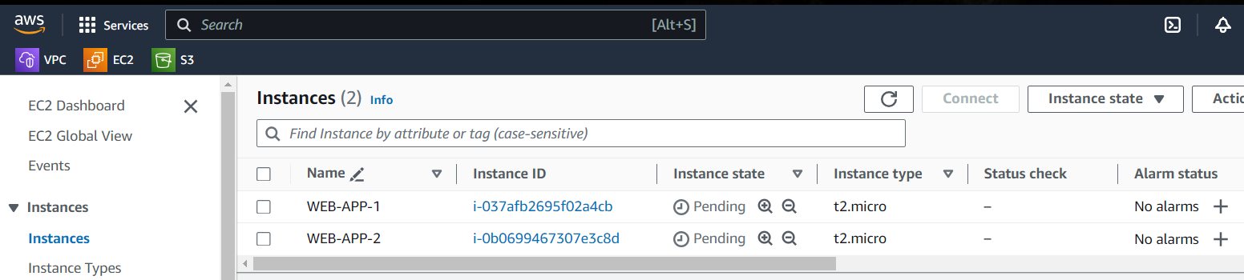

------------------------------------------------------------------------------------------------

**Step:2 – Installing webserver on the both instances:**

* Connecting both these instances:

**Instance:1**

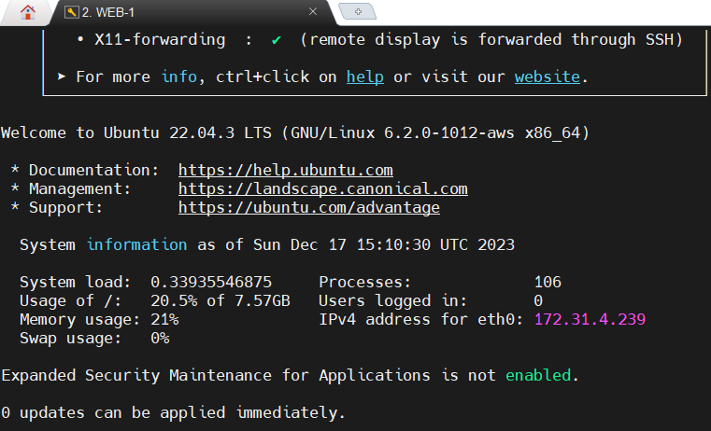

Instance:2

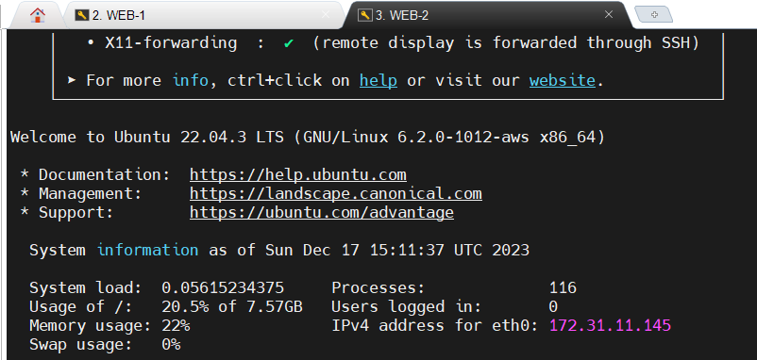

* Installing apache webserver on both instances:

**apt-get update**

**apt-get install -y apache2**



* Checking whether apache server is installed or not by using the command:

**apache2 --version**

**service apache2 status**

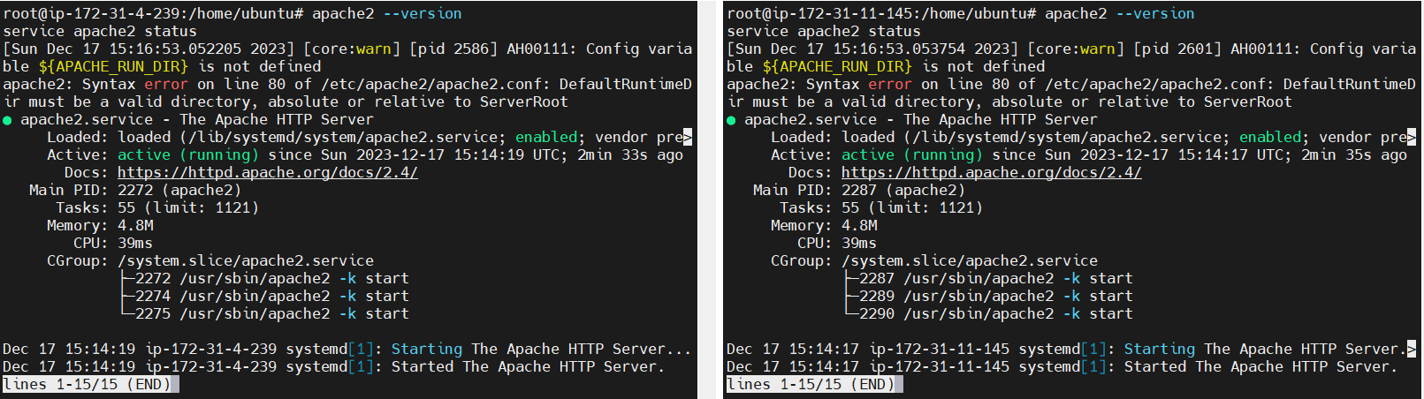

* Creating an index.html file in **/var/www/html**/ location:

Index.html file contains:

<!DOCTYPE html>

<html lang="en">

<head>

    <meta charset="UTF-8">

    <meta http-equiv="X-UA-Compatible" content="IE=edge">

    <meta name="viewport" content="width=device-width, initial-scale=1.0">

    <title>EC2 Server with AWS Route 53</title>

</head>

<body>

    <h1>This application is hosted on <strong>EC2 SERVER</strong> routed by <strong>AWS Route 53</strong>.</h1>

</body>

</html>

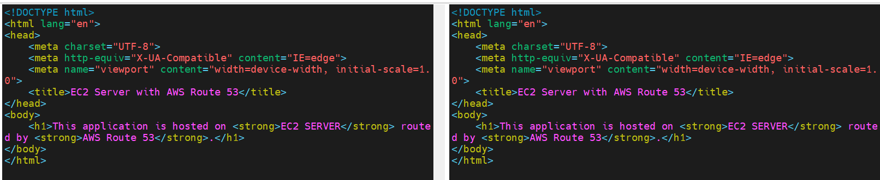



* Now copy the public ip address of the both the instances and paste this ip address on the browser:

**Instance:1**

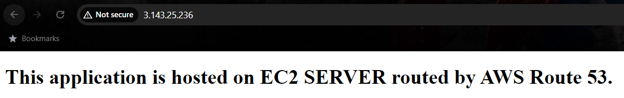

**Instance:2**

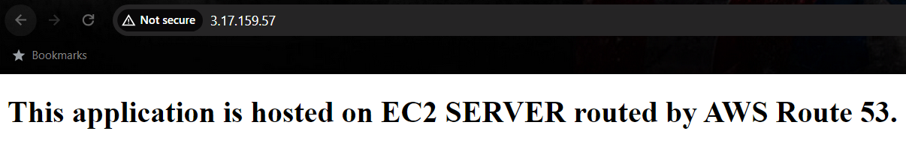

------------------------------------------------------------------------------------------------

**Step:3 – Creating an Application LoadBalancer:**

* On the EC2 Management console, we can able to find out target groups on left side, just click that one:

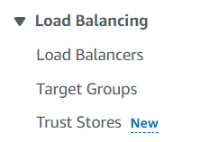

* Then click create target group:

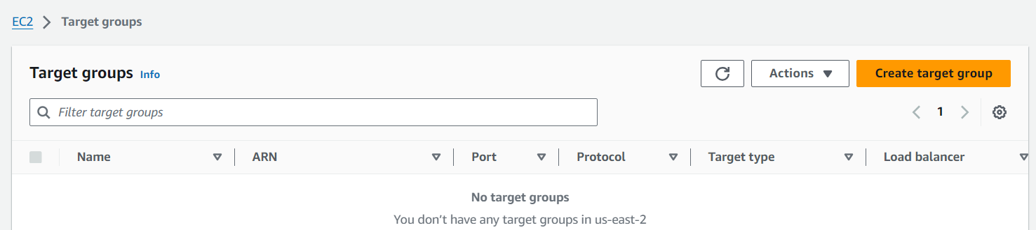

* Then select instances option:

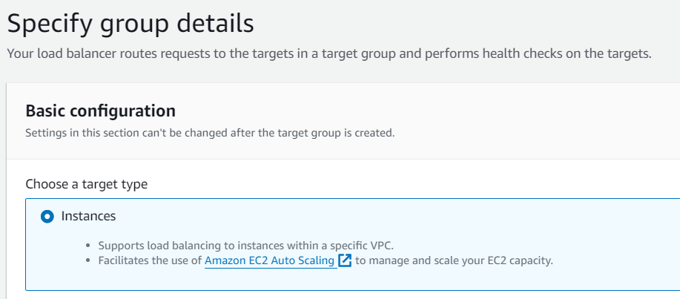

* Then **name** the target group name according to your wish, and then select **IPv4** for IP address type:

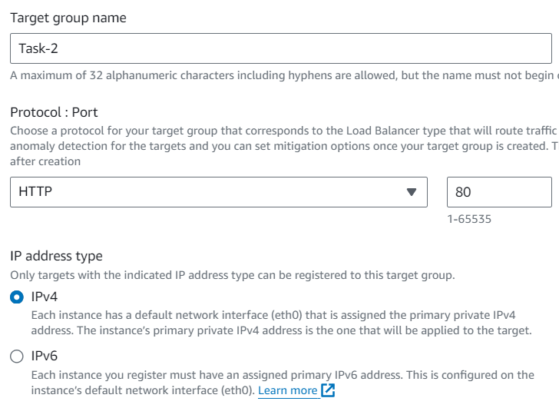

* The select the VPC where the instances have been created:

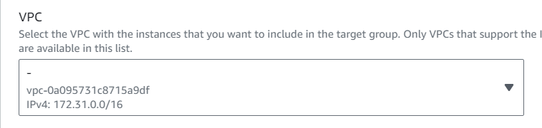

* Then click next:

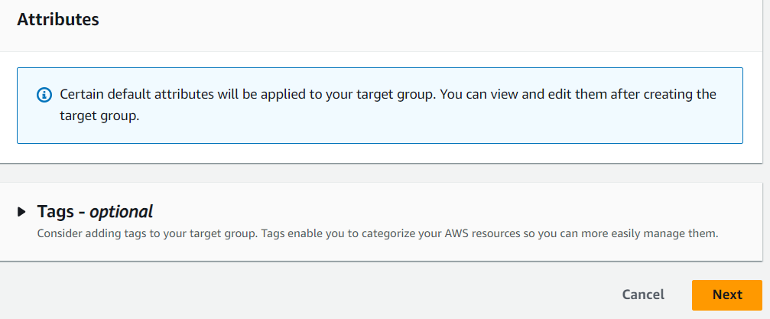

* Then select the instances as targets:

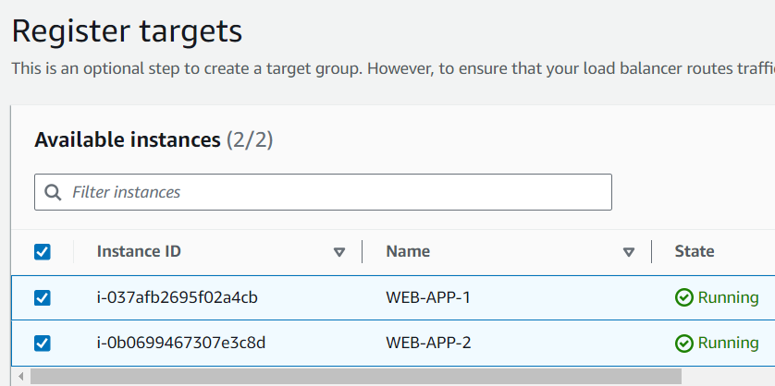

* Then select the option include as pending below, to **include these instances as targets:**

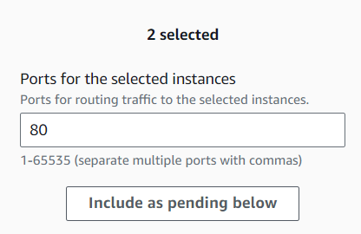

* Then click create target group:

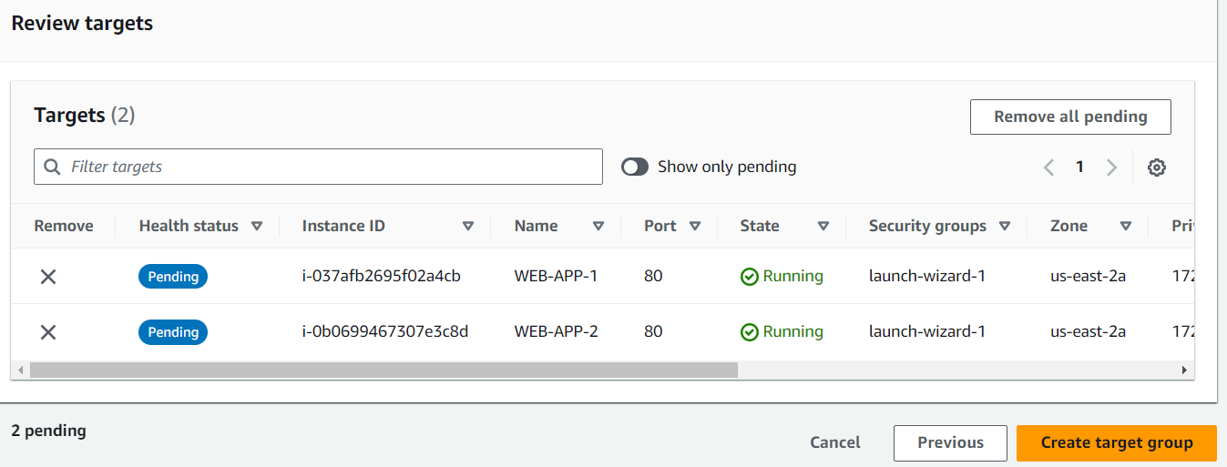

* The target group has been created successfully:

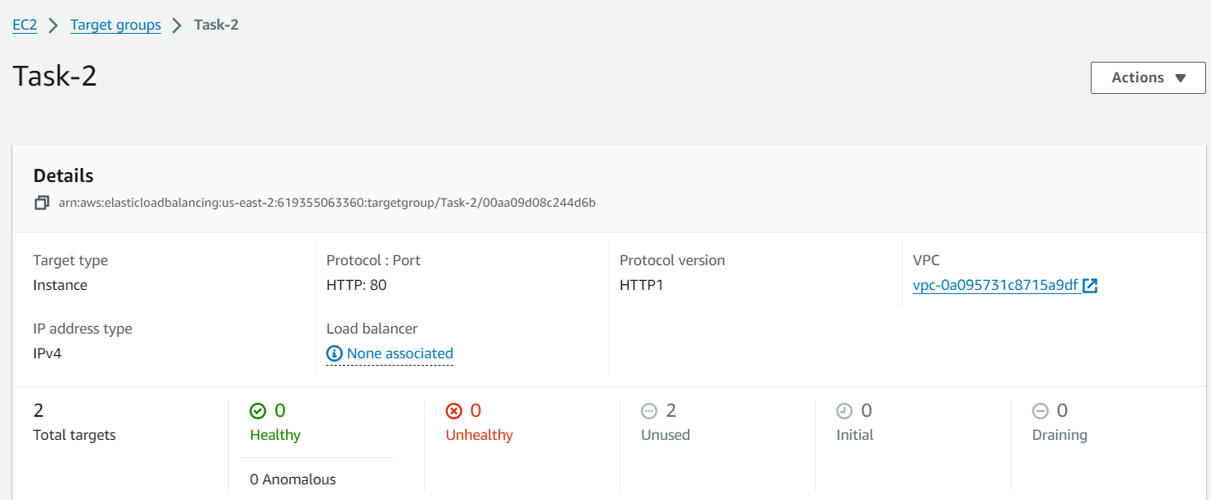

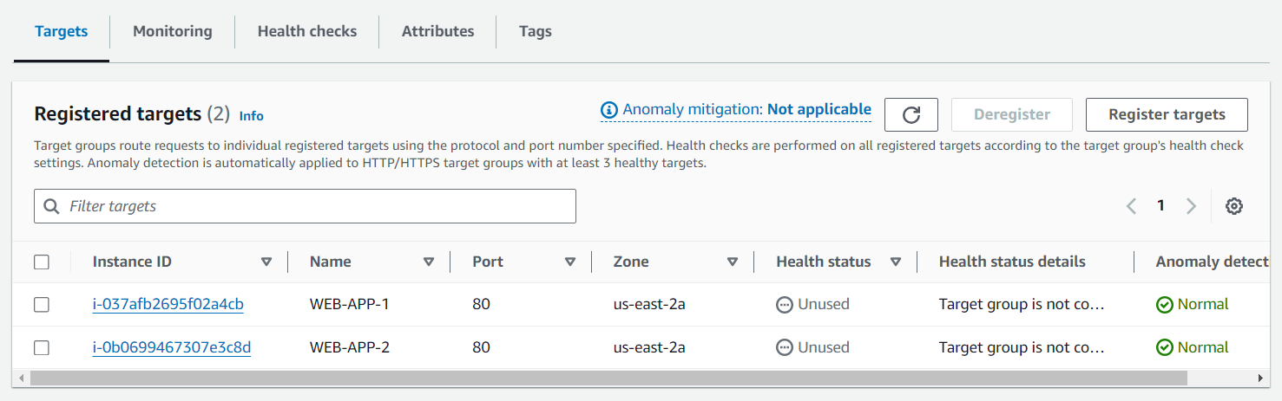

* Then we need to create Application LoadBalancer, for that click LoadBalancer on the left side of EC2 Management Console:

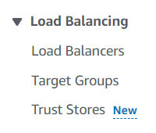

* Then click create load balancer:

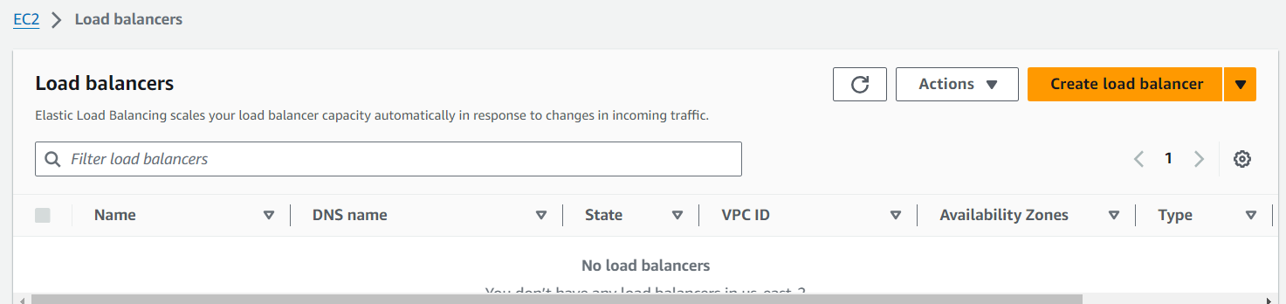

* Then click application load balancer:

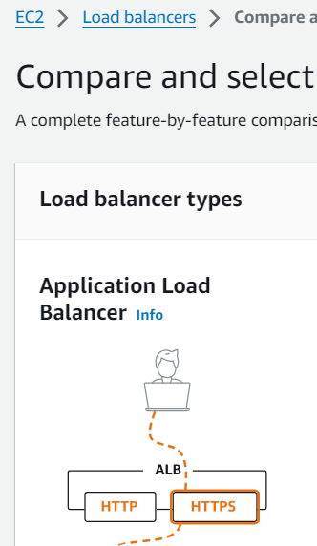

* Then name the load balancer according to your preferences:

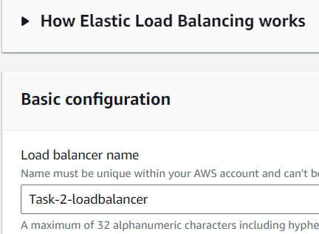

* Then click **internet-facing and IPv4:**

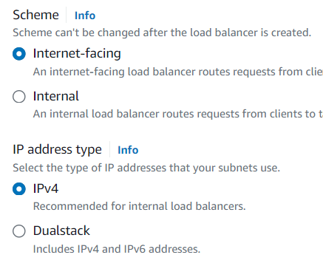

* Then select the VPC, where the instances have been created and select the availability zone:

**Note: Minimum two availability zones must be selected.**

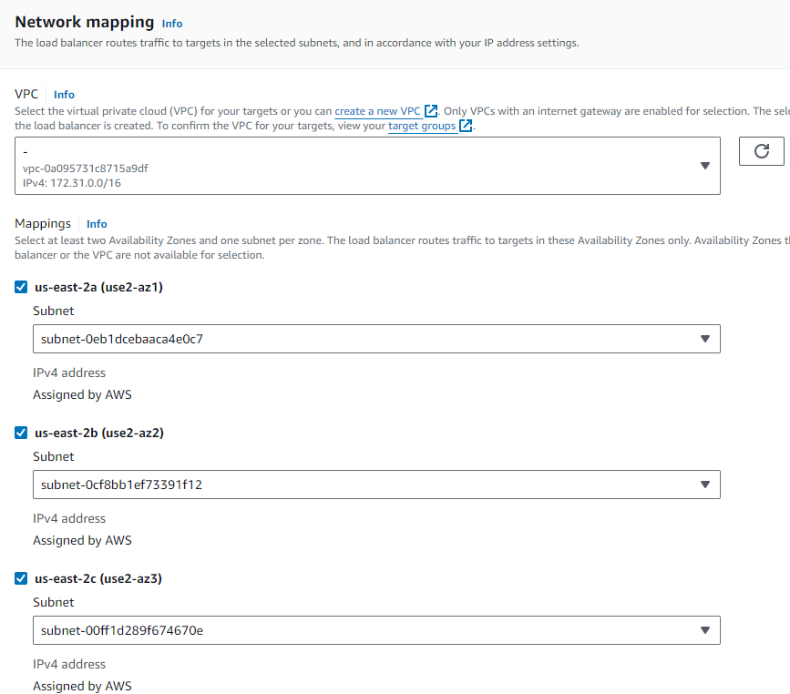

* The select the security groups, according to your preferences:

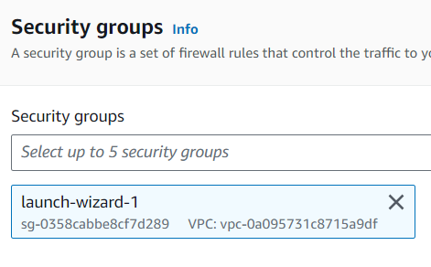

* Then select the target group for this load balancer:

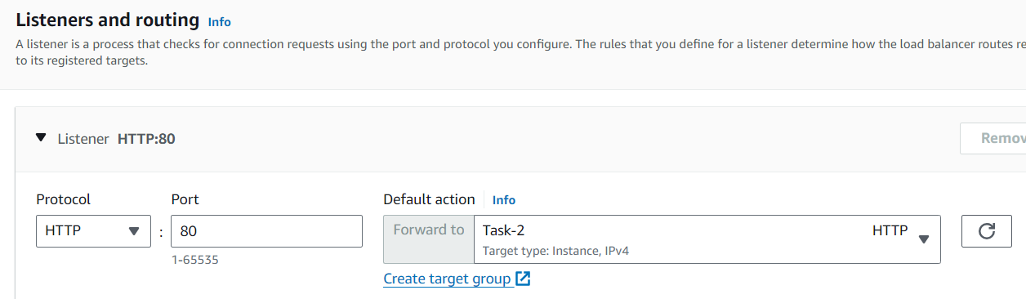

* Then click create load balancer:

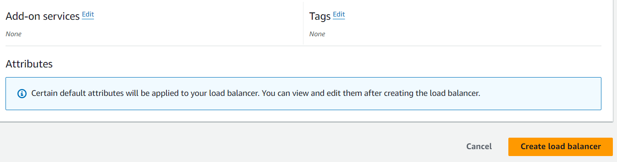

* The load balancer has been created successfully:

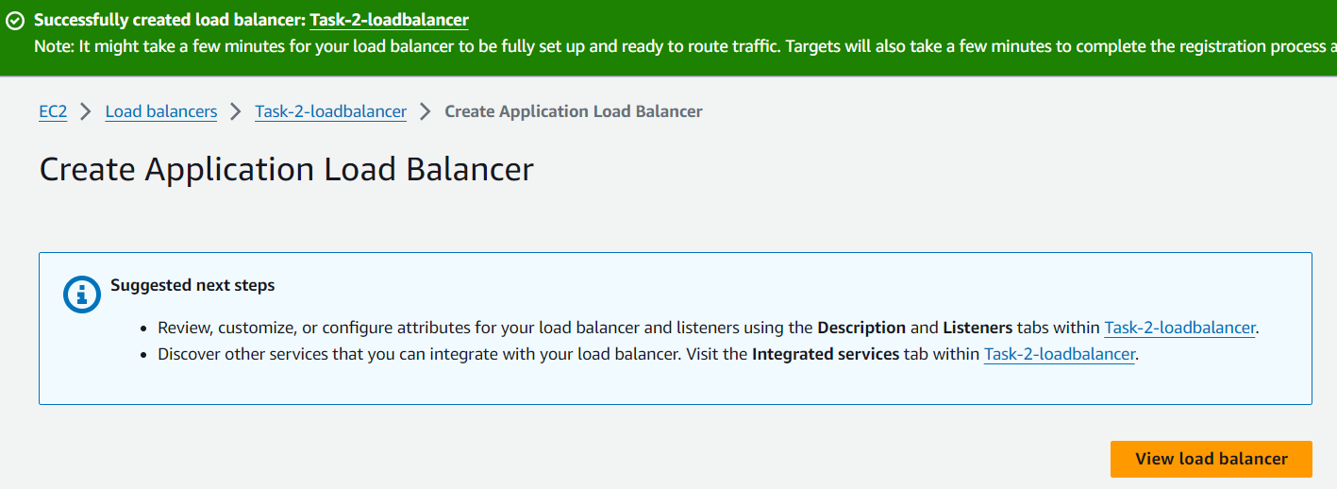

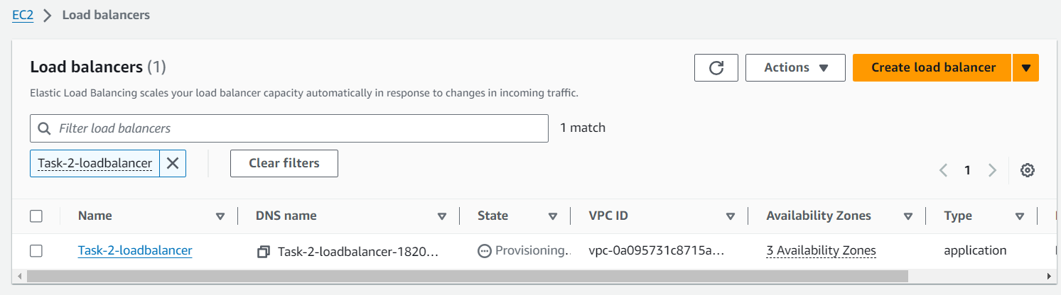

------------------------------------------------------------------------------------------------

**Step 4 – Creating a Hosted Zone on Amazon Route 53:**

* For Route 53 service search Route 53 on service panel:

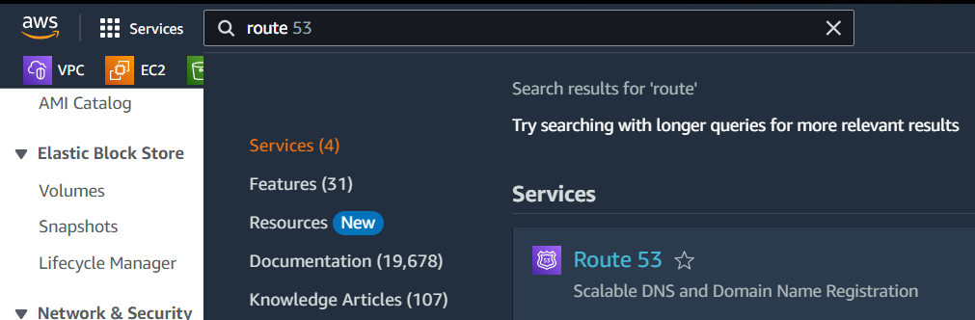

* Then click create hosted zone:

Note: using a domain name from third party:

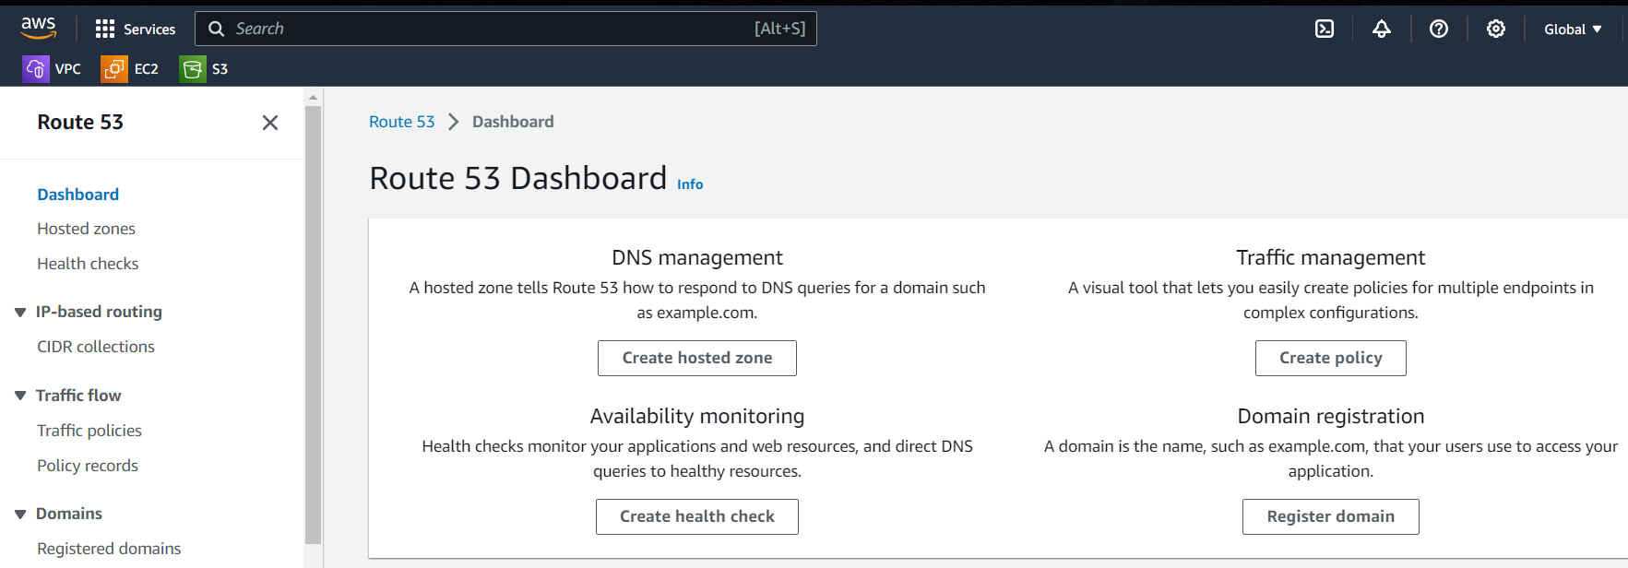

* Then enter domain name of yours as it is. For example: **ravivarman.xyz**

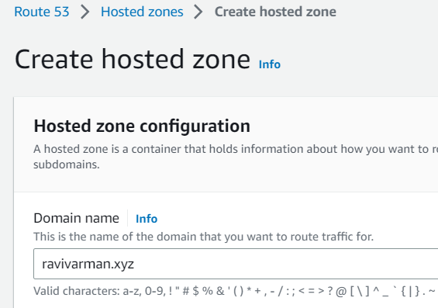

* Then select public hosted zone option: and click create hosted zone:

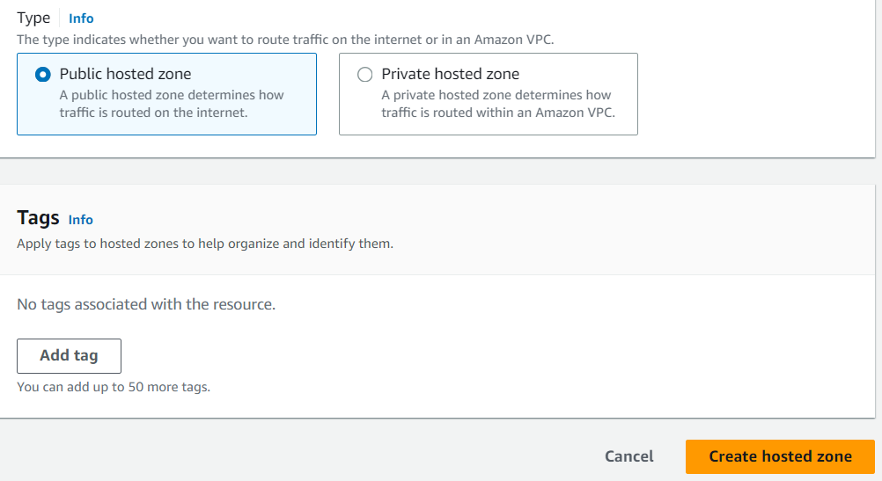

* Hosted zone has been created successfully:

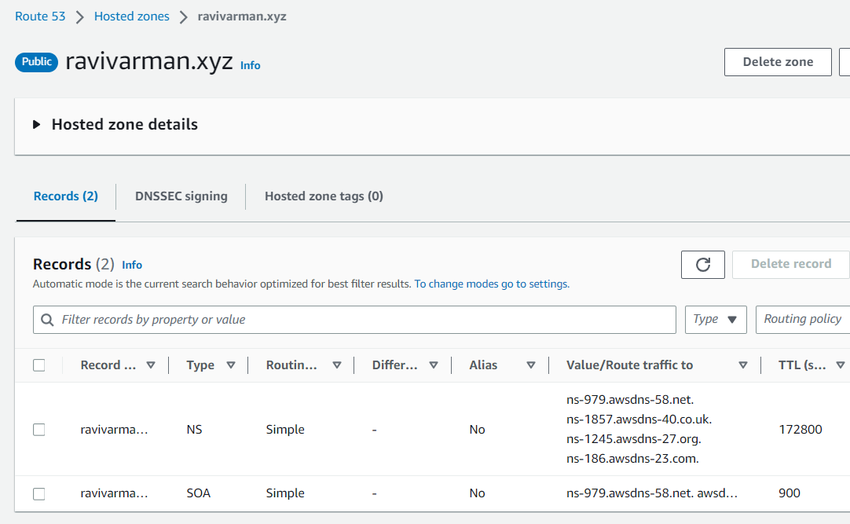

* **Copy the name servers of this hosted zone because nameserver of the domain name and hosted zone should be same:**

**Hosted zone: name servers:**

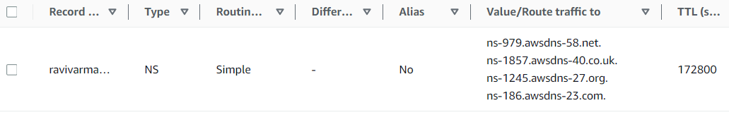

**Domain name: name servers**

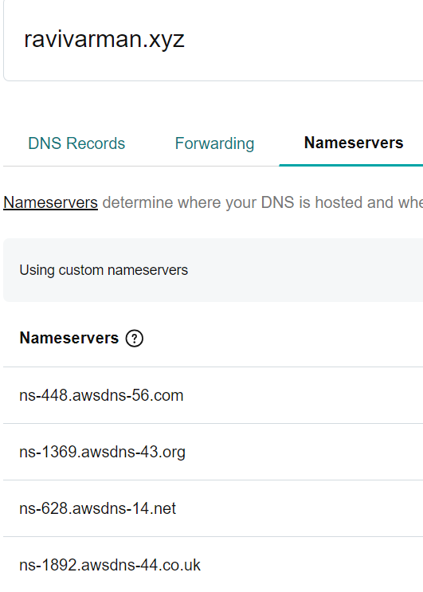

**Before:**

|  |  |
| --- | --- |
| **Hosted zone: name server** | **Domain name: name server** |
| ns-979.awsdns-58.net | ns-448.awsdns-56.com |
| ns-1857.awsdns-40.co.uk | ns-1369.awsdns-43.org |
| ns-1245.awsdns-27.org | ns-628.awsdns-14.net |
| ns-186.awsdns-23.com | ns-1892.awsdns-44.co.uk |

**After:**

|  |  |
| --- | --- |
| **Hosted zone: name server** | **Domain name: name server** |
| ns-979.awsdns-58.net | ns-979.awsdns-58.net |
| ns-1857.awsdns-40.co.uk | ns-1857.awsdns-40.co.uk |
| ns-1245.awsdns-27.org | ns-1245.awsdns-27.org |
| ns-186.awsdns-23.com | ns-186.awsdns-23.com |

* Then create record by clicking create record option:

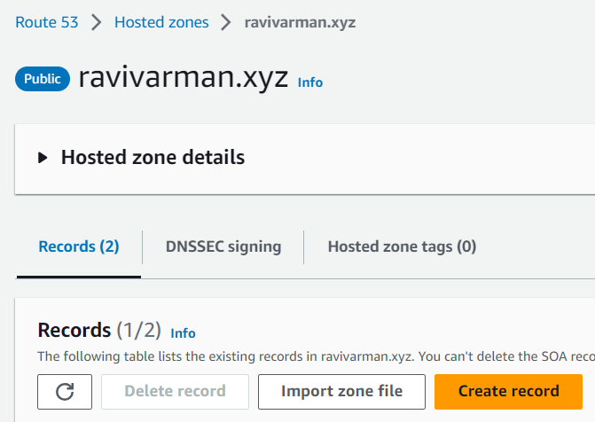

* Then click **alias, after that application load balancer:** then after that select the **routing policy**, here I am selecting **simple routing.**

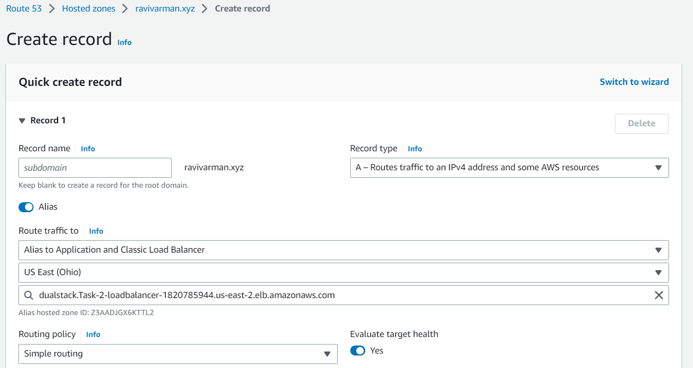

* Then click create records option: to add this record

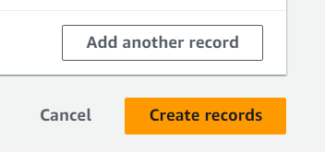.

* The record has been successfully:

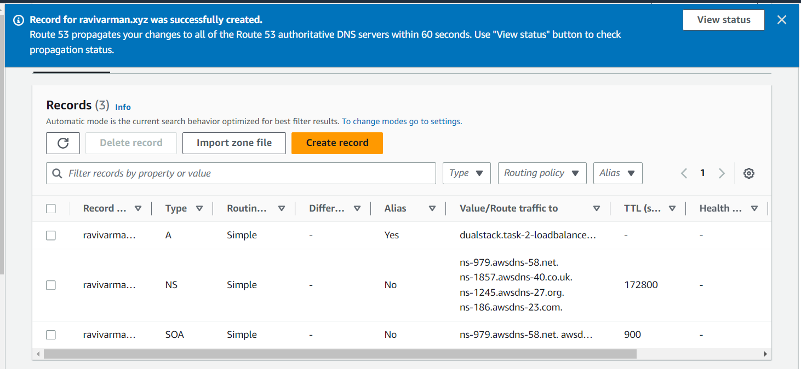

* The record has been sync’d perfectly:

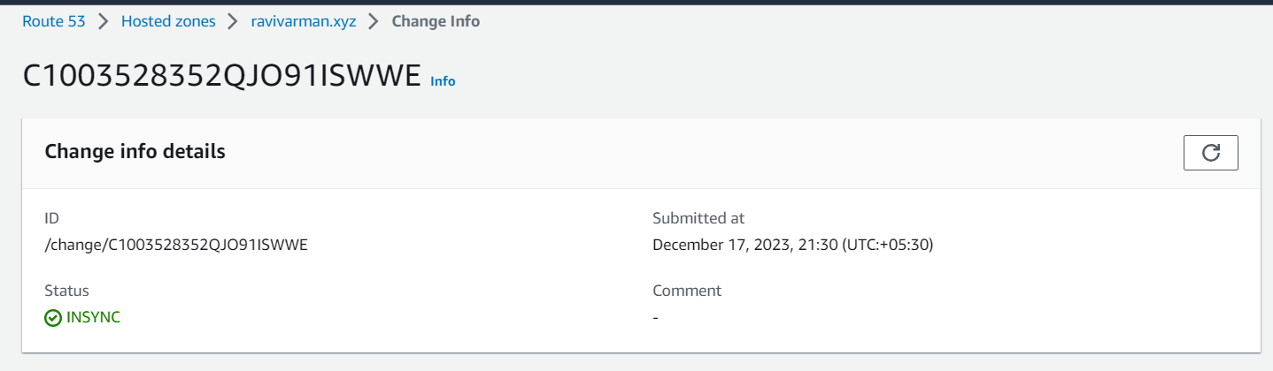

**Note: Because of the domain name is purchased on third party, so it will take more time to deflect changes on domain name.**

* After few minutes (10 minutes), copy paste the DNS name on browser:

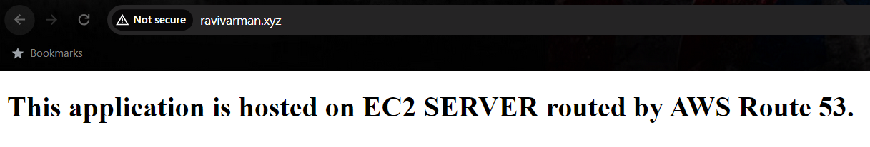

We can able to see the webserver output on domain name:

* Now let us make change in code, on webserver:

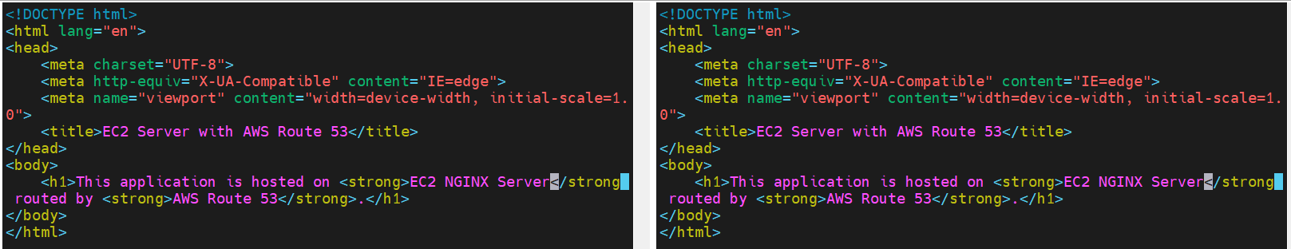

**After making changes:**

**Instance:1**

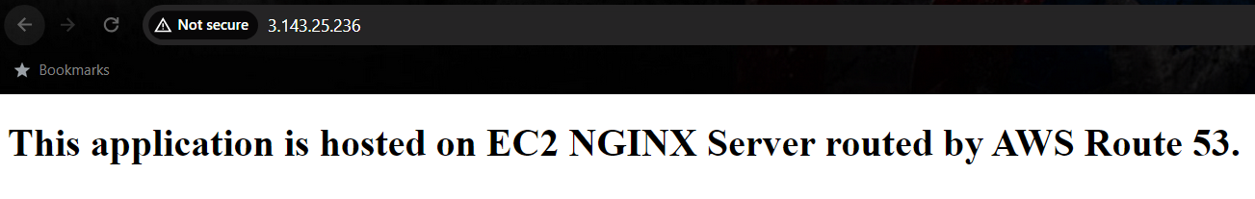

**Instance:2**

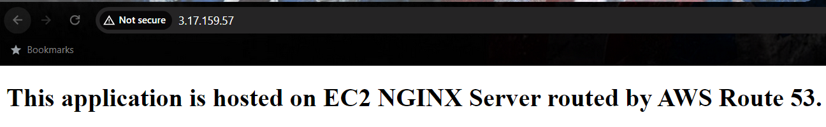

**Load balancer output:**

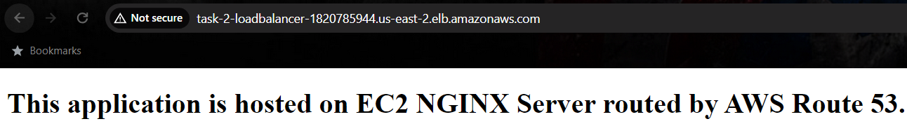

**DNS output:**

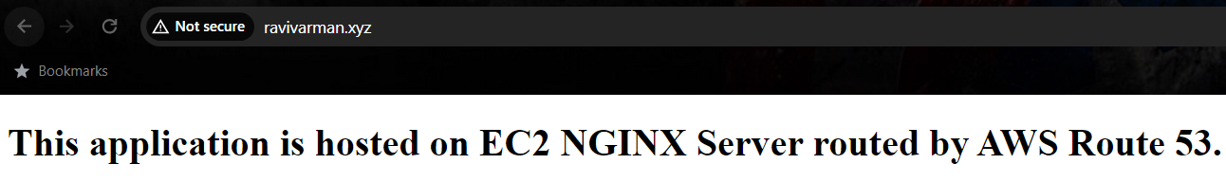

Note: The changes had been deflected to the domain name successfully:

------------------------------------------------------------------------------------------------

**Benefits of doing above task:**

* **Scalability:** Easily handle varying levels of traffic by adding or removing EC2 instances dynamically.
* **High Availability:** Distribute traffic across multiple instances, reducing the risk of downtime and ensuring continuous service availability.
* **Optimized Performance:** ALB intelligently routes requests to healthy instances, optimizing the performance of the web application.
* **DNS Routing:** Utilize Route 53 to create a user-friendly domain name and route traffic to the appropriate instances.
* **Cost-Efficiency:** Pay only for the resources you use, and utilize Auto Scaling to adapt to changing demand, optimizing cost-effectiveness.